**Project Structure**

Create a Project folder which contains files as shown below

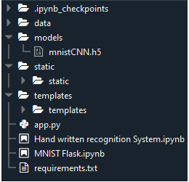

* We are building a Flask Application which needs  HTML pages stored in the templates folder and a python script app.py for server side scripting.
* The model is built in the notebook Hand written recognition system.ipynb
* We need the model which is saved and the saved model in this content is mnistCNN.h5
* The static folder will contain js and css files.
* The templates mainly used here are main.html and index6.html for showcasing the UI